IST 659 Database Administration and Database Management Concepts

Section M404

A Database for Recommendations

on Spices and Recipes

Jennifer Mead

# Summary

Recommendation engines are big business. They are used by many successful companies including Amazon, Netflix, Stitch Fix, and Facebook. Those companies have entire teams devoted to giving their customers recommendations in order to drive usage, engagement, and sales. For my project, I’m creating a database that can be used to give simple recommendations for recipes and spices.

I buy my spices from Penzey’s, a company with a devoted following; there is even a Facebook group for fans of the spices so that they can share recipes, ask for advice, and give recommendations. Common questions that are posted in the Facebook group on a daily basis include things like:

* “I want to make an entrée that tastes herby. What should I make?”
* “Which spices are peppery?”
* “I have a ton of spaghetti squash. What recipe should I try?”
* “I’m allergic to turmeric and want to make a soup. What should I cook?”
* “I just bought some 33rd & Galena [a spice blend]. What does it go with?”
* “I know other people have asked, but I can’t find it. Where’s the list of all the recipes we’ve collected?”

The recommendations that people post are enthusiastic, but imprecise. You can be sure that if you ask for a recipe without cinnamon that you’ll get 20 great ideas… and three people telling you to use cinnamon.

For my project, I’m creating a basic recommendation system. You can ask some common questions, and it will suggest recipes and spices that match your criteria.

## What’s the business case?

For the simple database I’m making, the benefit is just for me. But Penzey’s ([www.penzeys.com](http://www.penzeys.com)) would be served well by adding a recommendation feature to their site. They currently have no recipes on their site at all, even though most of their spices are used in food. They do have a basic feature that lists similar products on each product page.

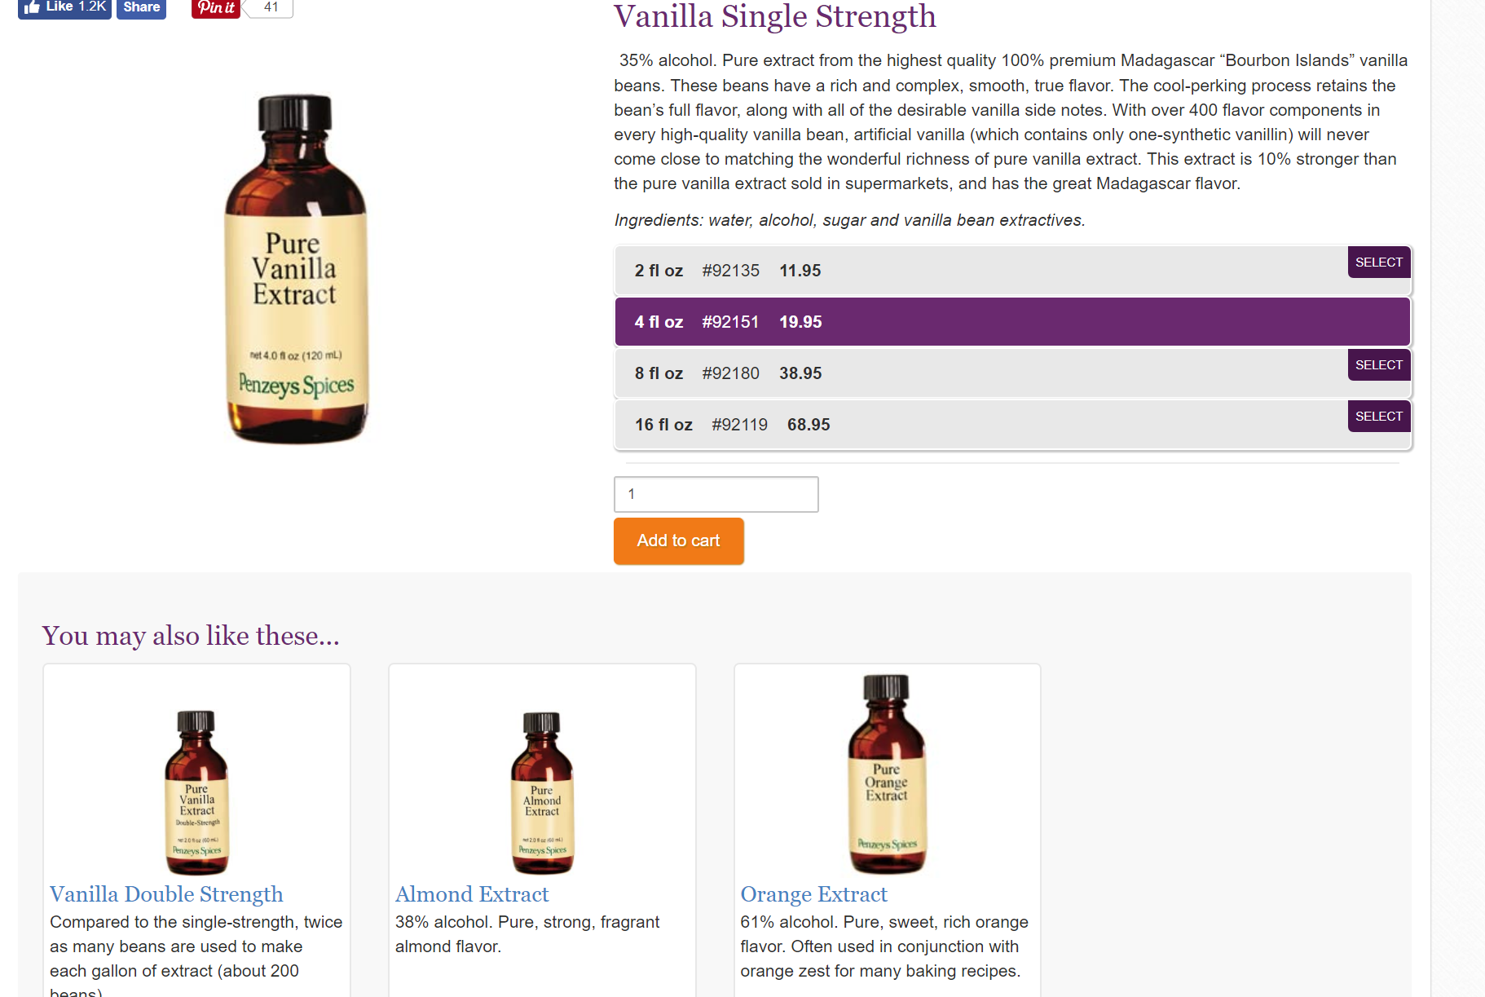

This seems to be based on their categories. If you look at an item in the “baking” category, you see other products in the same category. And I have in fact chosen products that were suggested in this way, so this feature is a good start, but there are many other opportunities here.

Amazon’s recommendation features are integrated throughout its retail experience, including “Your Amazon.com”, “Recommended For You”, “Improve Your Recommendations”, “Frequently bought together”, “Customers who bought this item also bought”, “Customer reviews”, “Read reviews that mention”, “Verified purchase”, and many more.

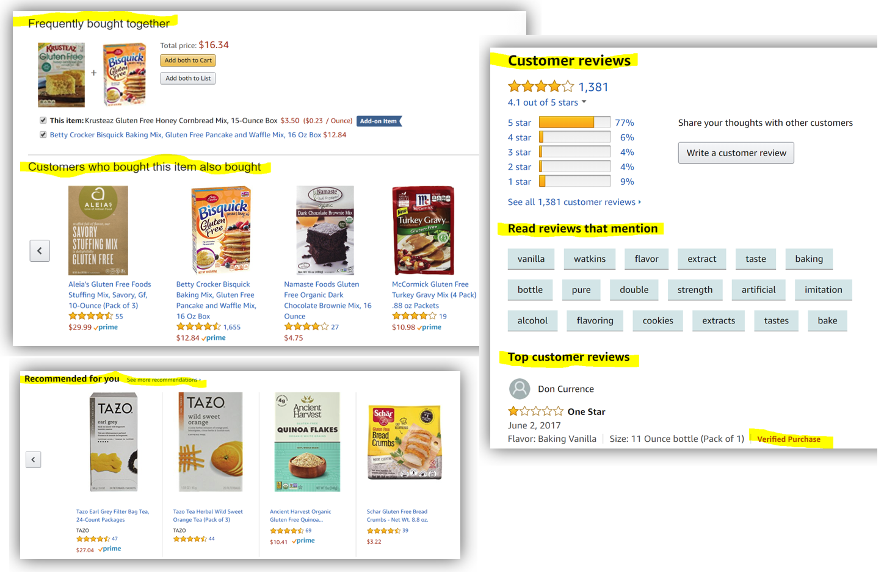

Some sources estimate that Amazon makes 35% of their sales from recommendations, but frankly that sounds like an outdated number to me. (2013, www.mckinsey.com)

Read more:

* <https://www.cs.umd.edu/~samir/498/Amazon-Recommendations.pdf>
* <https://aws.amazon.com/mp/scenarios/bi/recommendation/>

**Netflix** used to give recommendations based on ratings, but they’ve largely abandoned that approach in favor of analyzing user viewing behaviors. Netflix doesn’t care what you watch, just that you keep watching.



Read more:

* <https://www.wired.com/2013/08/qq_netflix-algorithm/>
* <http://delivery.acm.org/10.1145/2850000/2843948/a13-gomez-uribe.pdf?ip=73.35.196.177&id=2843948&acc=OA&key=4D4702B0C3E38B35%2E4D4702B0C3E38B35%2E4D4702B0C3E38B35%2EE5B8A747884E71D5&CFID=1014336671&CFTOKEN=27862660&__acm__=1512695890_28a4d16ec07f7627a1ccd4e149480756>

**Facebook** makes its money from ads, and its goal is to keep you on Facebook as long as possible (engagement) so that it can show you more ads. By targeting you with ads that you are most likely to be interested in, it increases the clicks and conversions on those ads. It combines your preferences (likes, follows) with web searches, the text of your gmail and Google Calendar, searches on other sites, location services, and more.

* <https://www.facebook.com/business/a/custom-audiences>
* <https://developers.facebook.com/docs/marketing-api/reference/ad-recommendation/>
* <http://quinonero.net/Publications/predicting-clicks-facebook.pdf>

**Stitch Fix** is a clothing subscription box. You fill out surveys about what you like, and a “stylist” chooses five items for you per month and sends them to you. If you don’t like them, you send them back. They do have people acting as stylists, but a good percentage of the recommendations come from analyzing your preferences, what you send back, and the comments you make about what you are looking for.

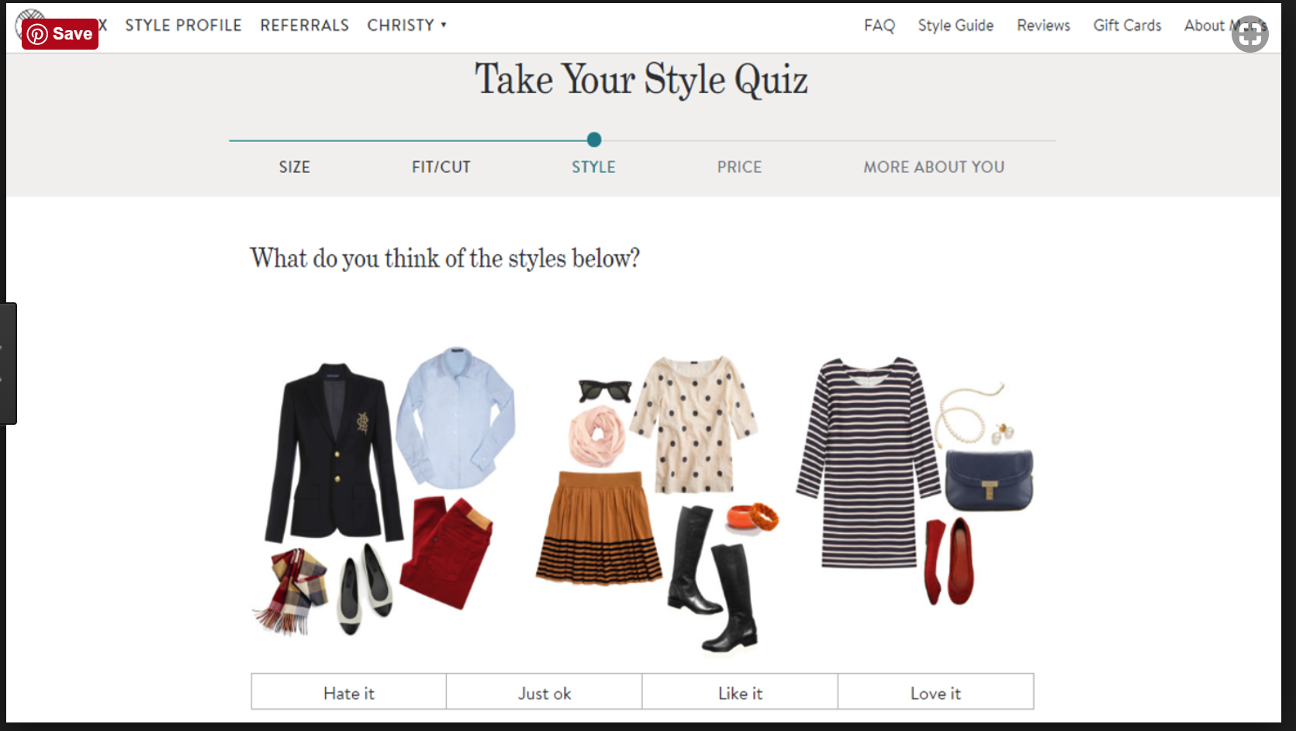

Read more:

* <https://hbr.org/2015/05/what-stitchfix-figured-out-about-mass-customization>
* <http://algorithms-tour.stitchfix.com/>

# Conceptual Model

## Business rules and my spice data

For any kind of recommendation, it’s important to think about how the data is used in context. For spices and recipes, there are some tricks in the way we talk about food. For example, vanilla is a spice; it’s an ingredient; and it’s a flavor. Any system I come up with has to be flexible in the way those words are used, allowing connections across categories. And because people use different phrases to talk about the same thing (“dill” vs. “dill weed”, e.g.), I’m likely to find more matches if I do a search in a free-form text field, rather than forcing a strict categorization of each ingredient and recipe.

Other business rules that influence how I’ve set up the database:

* Every recipe has at least one spice. There are recipes in the world without spices, but since this is a recommendation engine for a spice company, we don’t track those recipes here.
* A spice can exist without being in a recipe. Maybe you haven’t figured out how to use star anise yet.
* A spice can be a blend of other spices. For example, there is no curry plant. Curry is a combination of more than a dozen other spices, including turmeric, cayenne, cumin, cardamom, and coriander.
* A term like “pepper” can be a spice, a flavor, and an ingredient. There are several “pepper” entries in the database, including black pepper, white pepper, cayenne, red pepper flakes, peppercorns, etc.
* One spice can have multiple preparations: ground ginger, candied ginger, pickled ginger, etc. These would all be listed as separate spices in this database.
* SpiceCategory and RecipeFlavor have similar values. SpiceIngredient, SpiceName, and RecipeIngredients have similar values.
* There can be more than one spice with the same name. I have two curries in my pantry.
* There can be more than one recipe with the same name, e.g. Grandma’s Chicken Soup.
* A RecipeSource can be a URL to a recipe, to a cookbook, the name of a cookbook, the name of a cook, or can be blank.
* MealType forces only one value for each recipe. Yes, you could eat pancakes for dinner, but in this case MealType is similar to filing a recipe card in a recipe box; you have to put it in one of the categories.

# Conceptual model

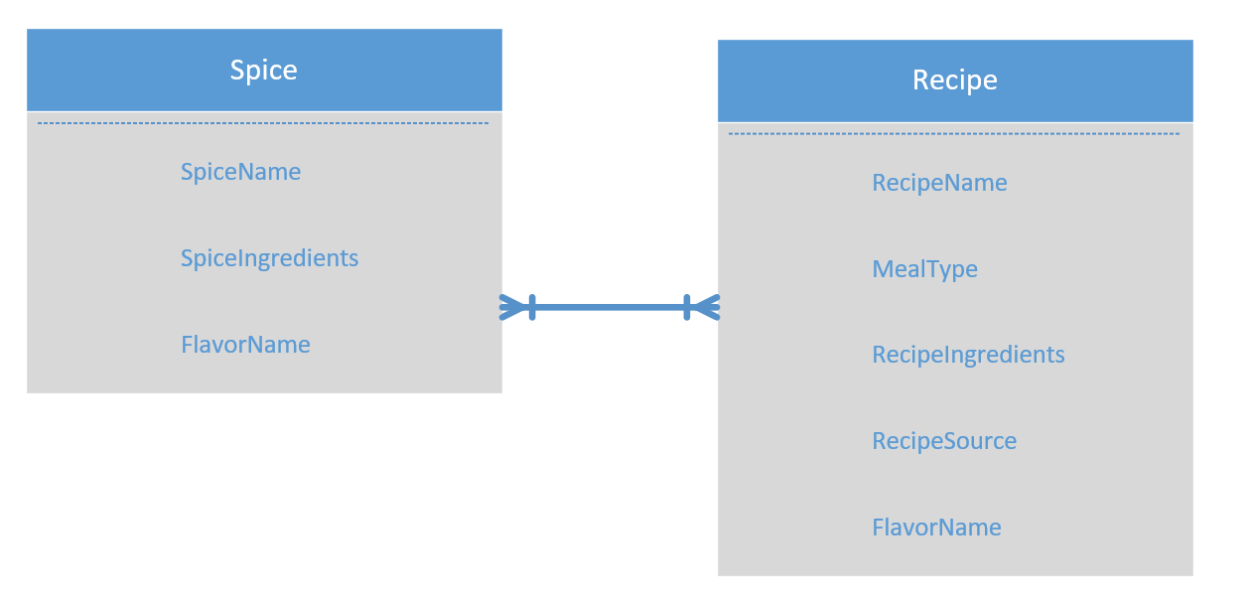

## Sample data

|  |  |
| --- | --- |
| Sample data | Glossary |
|  | In the Spice table:   * SpiceName is what the spice is normally called on the jar (cinnamon, berbere, ground ginger) * SpiceCategory is a description like peppery, oniony, Chinese, Thai. * SpiceIngredients may only have one ingredient (cinnamon) or if the spice is a blend could have a long list (curry) |
|  | In the Recipe table:   * RecipeName is what the recipe is called (apple pie, salmon with dill) * MealType is like the category in the recipe file box (entrée, dessert, vegetable side) * RecipeIngredients is the long list of ingredients, but not the instructions on how to make the dish * RecipeSource could be a URL, name, or blank * FlavorCategory is a description like peppery, oniony, Chinese, Thai |

# Normalized Logical Model

* In normalizing the database, I kept the Spice and Recipe tables. I added tables for MealType and FlavorCategory, because these are set lists that the spices and recipes choose from. I also added two junction tables, SpiceFlavor and RecipeFlavor, to turn the many-to-many relationship (between spices, flavors, and recipes) into one-to-many relationships.
* Data types:
  + All primary keys are surrogate keys generated by SQL from int identity. I used the naming convention of including ID in the attribute name.
  + All foreign keys are int.
  + All short names are either char(30) or char(50) based on the typical length of the sample data. See SpiceName, RecipeName, MealTypeName, and FlavorDescription.
  + All longer descriptions are either varchar(200) or varchar(500) based on sample data. See SpiceIngredients, RecipeIngredients, and RecipeSource.

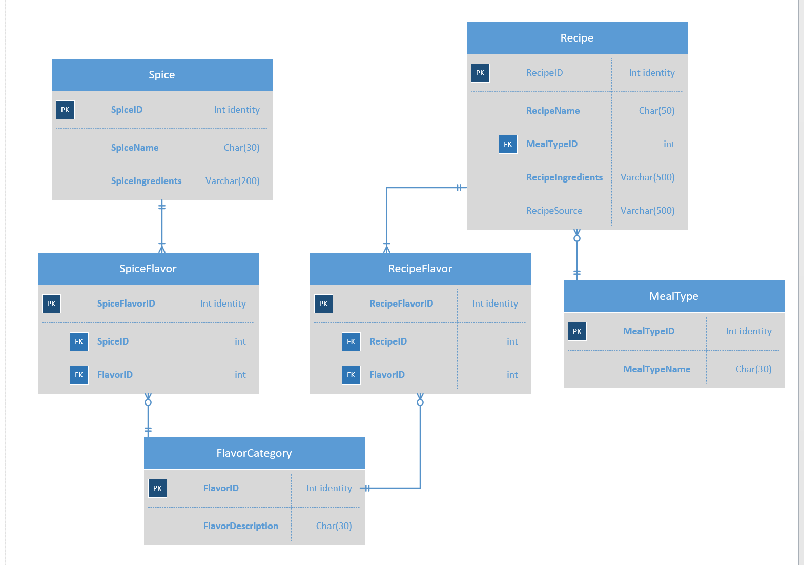

It can also be useful to picture the data in a logical diagram, with sample data in place of keys.

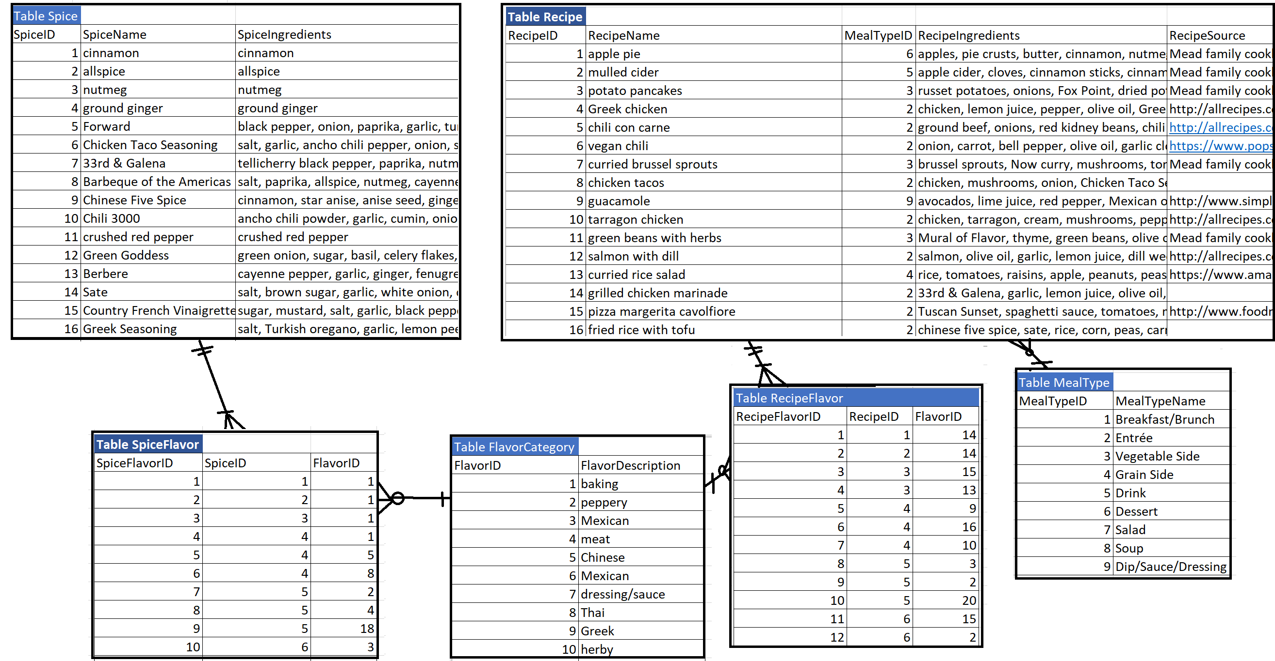

# Physical Database Design

* *Provide your Data Definition Language (DDL) code to build the database tables and any objects such as stored procedures, views, and functions.*
* *Make sure your SQL code has adequate comments throughout that describe what the code does and provide commentary on the object being implemented (what are the paramters, assumptions, and controls on a stored procedure, for example).*
* *Also include the necessary code to remove these objects.*
* *You should be able to repeatedly execute the code in this section without error.*

## Table creation

Use the following code to Drop and Create each table in the database.

Because tables are dropped first, you can run this code repeatedly without errors.

/*First drop tables so that if they already exist, you don't get an error*/

/*Drop them in the opposite order of how they are created*/

IF EXISTS (SELECT * FROM INFORMATION_SCHEMA.TABLES

WHERE TABLE_NAME = 'RecipeFlavor')

BEGIN

DROP TABLE RecipeFlavor

END

GO

IF EXISTS (SELECT * FROM INFORMATION_SCHEMA.TABLES

WHERE TABLE_NAME = 'SpiceFlavor')

BEGIN

DROP TABLE SpiceFlavor

END

GO

IF EXISTS (SELECT * FROM INFORMATION_SCHEMA.TABLES

WHERE TABLE_NAME = 'Recipe')

BEGIN

DROP TABLE Recipe

END

GO

IF EXISTS (SELECT * FROM INFORMATION_SCHEMA.TABLES

WHERE TABLE_NAME = 'Spice')

BEGIN

DROP TABLE Spice

END

GO

IF EXISTS (SELECT * FROM INFORMATION_SCHEMA.TABLES

WHERE TABLE_NAME = 'FlavorCategory')

BEGIN

DROP TABLE FlavorCategory

END

GO

IF EXISTS (SELECT * FROM INFORMATION_SCHEMA.TABLES

WHERE TABLE_NAME = 'MealType')

BEGIN

DROP TABLE MealType

END

GO

/*create tables*/

/*MealType is a lookup table*/

CREATE TABLE MealType(

MealTypeID int identity primary key

, MealTypeName char(30) not null

)

GO

/*FlavorCategory is a lookup table*/

CREATE TABLE FlavorCategory(

FlavorID int identity primary key

, FlavorDescription char(30) not null

)

GO

/*Spice is one of the main tables, showing spices and their ingredients*/

CREATE TABLE Spice(

SpiceID int identity primary key

, SpiceName char(30) not null

, SpiceIngredients varchar(200) not null

)

GO

/*Recipe is one of the main tables, showing recipes, their ingredients,

the meal type, and the source of the recipe*/

CREATE TABLE Recipe(

RecipeID int identity primary key

, RecipeName char(30) not null

, RecipeIngredients varchar(500) not null

, RecipeSource varchar(500)

, MealTypeID int FOREIGN KEY REFERENCES MealType(MealTypeID)

)

GO

/*SpiceFlavor is a junction table, to handle the 1-to-many

relationship between Flavors and Spices*/

CREATE TABLE SpiceFlavor(

SpiceFlavorID int identity primary key

, SpiceID int FOREIGN KEY REFERENCES Spice(SpiceID) not null

, FlavorID int FOREIGN KEY REFERENCES FlavorCategory(FlavorID) not null

)

GO

/*RecipeFlavor is a junction table, to handle the 1-to-many

relationship between Flavors and Recipes*/

CREATE TABLE RecipeFlavor(

RecipeFlavorID int identity primary key

, RecipeID int FOREIGN KEY REFERENCES Recipe(RecipeID) not null

, FlavorID int FOREIGN KEY REFERENCES FlavorCategory(FlavorID) not null

)

GO

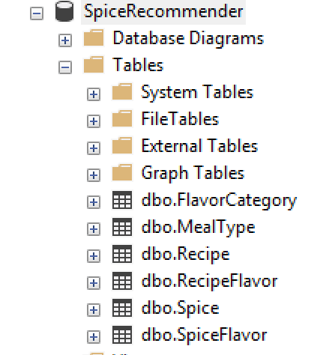

# Data Creation

Here are some representative SQL statements for inserting data

Most of the values in this database are required. When a value can be blank, either give it NULL or DEFAULT so the computer will fill it in. See Recipe’s field RecipeSource for an example.

/*Add a MealType*/

INSERT INTO MealType (MealTypeName)

VALUES ('Breakfast/Brunch')

/*Add a Recipe. RecipeSource can be blank. Either give NULL or DEFAULT if there is no value*/

INSERT INTO Recipe (RecipeName, MealTypeID, RecipeIngredients, RecipeSource)

VALUES ('apple pie', '6', 'apples, pie crusts, butter, cinnamon, nutmeg, allspice, sugar', null)

INSERT INTO Recipe (RecipeName, MealTypeID, RecipeIngredients, RecipeSource)

VALUES ('mulled cider', '5', 'apple cider, cloves, cinnamon sticks, cinnamon, orange', DEFAULT)

GO

SELECT * FROM Recipe

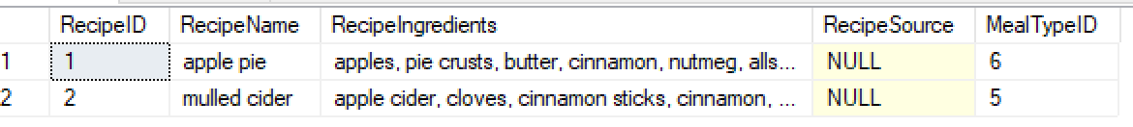

/*Add a spice*/

INSERT INTO Spice (SpiceName, SpiceIngredients)

VALUES ('cinnamon', 'cinnamon')

/*Add a flavor category*/

INSERT INTO FlavorCategory (FlavorDescription)

VALUES ('baking')

/*Add a junction between a recipe and one of its flavors*/

INSERT INTO RecipeFlavor (RecipeID, FlavorID)

VALUES ('1', '14')

/*Add a junction between a spice and one of its flavors*/

INSERT INTO SpiceFlavor (SpiceID, FlavorID)

VALUES ('1', '1')

# Data Manipulation

Here are some representative examples of how data are manipulated through updates and deletions.

/*Before updating a record, verify that you know what your where clause is targeting, then verify afterwards that the update was successful*/

SELECT * FROM Recipe

WHERE Recipe.RecipeName = 'apple pie'

UPDATE Recipe

SET RecipeIngredients = 'apples, pie crusts, butter, cinnamon, nutmeg, allspice, sugar, lemon juice'

WHERE Recipe.RecipeName = 'apple pie'

SELECT * FROM Recipe

WHERE Recipe.RecipeName = 'apple pie'

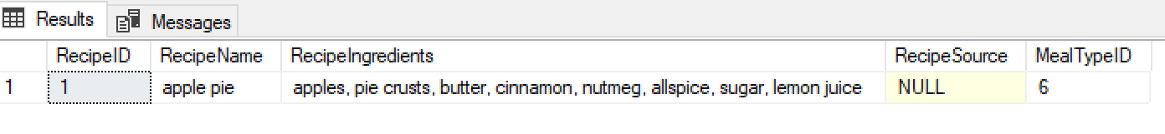

/*Delete a recipe and check that it is deleted*/

DELETE Recipe WHERE RecipeID = 2

SELECT * FROM Recipe

GO

# Answering Data Questions

For each of the sample questions, there is code and a screenshot of the results for a sample query.

## Questions to answer

* **“I want to make an entrée that tastes herby. What should I make?”**

/*“I want to make [an entrée] that tastes [herby]. What should I make?”

Equivalent to “I want to make [MealType] that tastes [RecipeFlavor]. Return all [Recipe] that match.”

Function with--

Input: mealtypename, flavor

Output: table with columns MealTypeName, RecipeName, FlavorDescription, RecipeSource

*/

CREATE FUNCTION dbo.MealWithFlavor (@mealtypename char(30), @flavorname char(30))

RETURNS TABLE

AS

RETURN

(

SELECT MealTypeName, RecipeName, FlavorDescription, RecipeSource

FROM Recipe

JOIN RecipeFlavor ON Recipe.RecipeID = RecipeFlavor.RecipeID

JOIN FlavorCategory ON RecipeFlavor.FlavorID = FlavorCategory.FlavorID

JOIN MealType ON MealType.MealTypeID = Recipe.MealTypeID

WHERE MealType.MealTypeName = @mealtypename

AND FlavorDescription = @flavorname

GROUP BY RecipeName, MealTypeName, FlavorDescription, RecipeSource);

GO

SELECT *

FROM dbo.MealWithFlavor ('entree','herby')

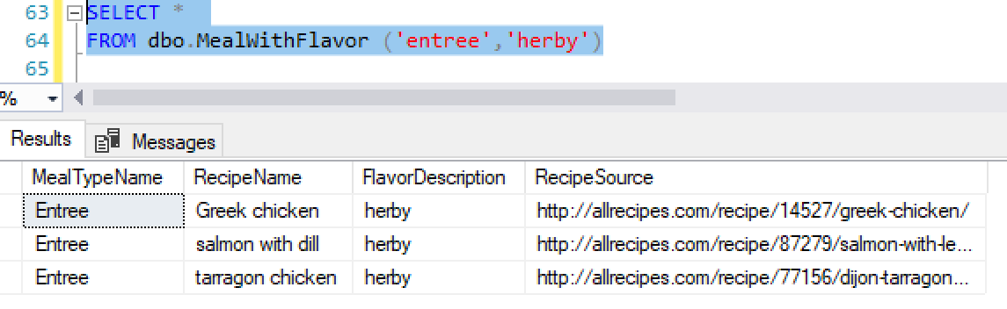

SELECT *

FROM dbo.MealWithFlavor ('soup', 'Indian')

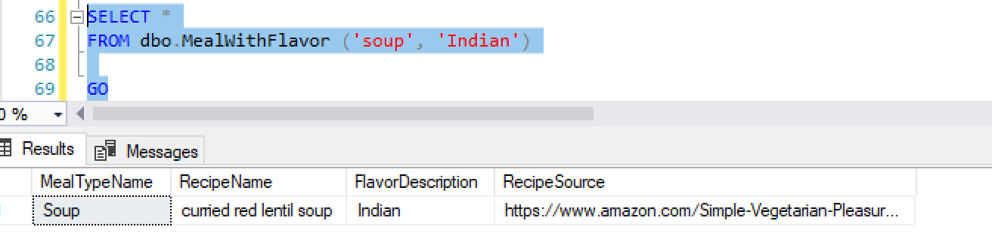

* **“Which spices are peppery?”**

/* "Which spices are peppery?"

Equivalent to "show me every [spice] that has a [flavor description = peppery]"

*/

CREATE FUNCTION dbo.SpiceHasFlavor (@flavor char(30))

RETURNS TABLE

AS

RETURN

(

SELECT Spice.SpiceName, Spice.SpiceIngredients, FlavorCategory.FlavorDescription

FROM Spice

JOIN SpiceFlavor

ON Spice.SpiceID = SpiceFlavor.SpiceID

JOIN FlavorCategory

ON SpiceFlavor.FlavorID = FlavorCategory.FlavorID

WHERE FlavorCategory.FlavorDescription = @flavor);

GO

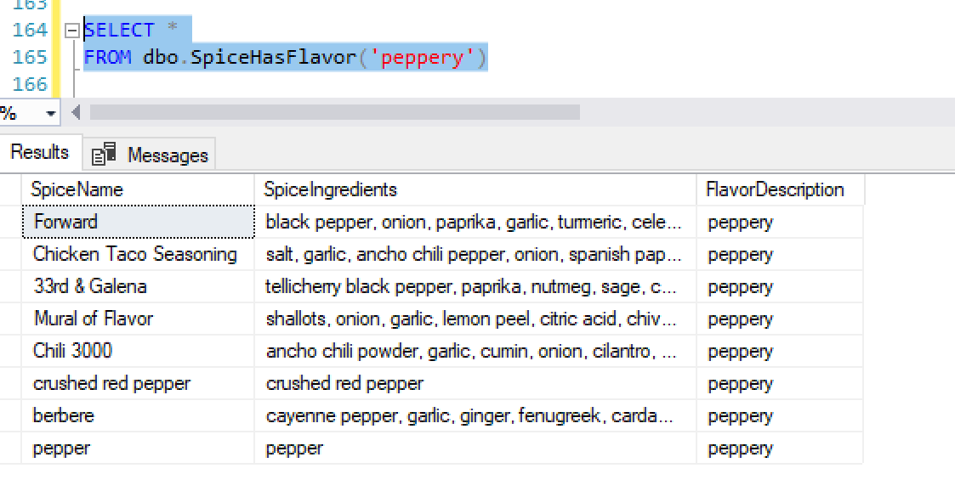

* **“I have a ton of spaghetti squash. What recipe should I try?”**

/*

"I have a ton of [spaghetti squash]. What should I make?"

Equivalent to "I have [ingredient]. Return all [recipe] with that [ingredient] IN [RecipeIngredients]."

*/

CREATE FUNCTION dbo.RecipeWithIngredient (@ingredient char(30) = NULL)

RETURNS TABLE

AS

RETURN

(

SELECT Recipe.RecipeName, Recipe.RecipeIngredients,

Recipe.RecipeSource

FROM Recipe

WHERE RecipeIngredients LIKE '%' + LTRIM(RTRIM(@ingredient)) + '%'

);

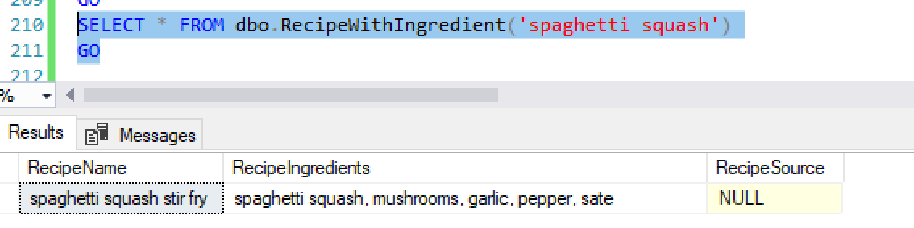

* **“I’m allergic to turmeric and want to make a soup. What should I cook?”**

/*

“I'm allergic to turmeric and want to make a soup. What should I cook?”

Equivalent to “I want to make [MealType] with NOT[RecipeIngredient]. Return all [Recipe] that match.”

*/

CREATE FUNCTION dbo.MealWithoutIngredient (@mealtypename char(30), @ingredient char(30))

RETURNS TABLE

AS

RETURN

(

SELECT RecipeName, RecipeIngredients, RecipeSource

FROM Recipe

JOIN MealType

ON Recipe.MealTypeID = MealType.MealTypeID

WHERE RecipeIngredients NOT LIKE '%' + LTRIM(RTRIM(@ingredient)) + '%' AND MealTypeName = @mealtypename

)

GO

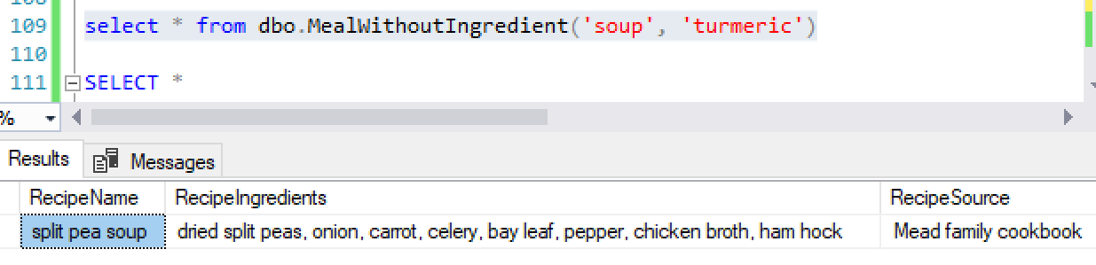

* **“I just bought some 33rd & Galena [a spice blend]. What does it go with?”**

/* "I just bought some 33rd & Galena. What does it go with?"

Equivalent to "For [spice] what are all the [flavor descriptions]?"

*/

DROP FUNCTION dbo.AllFlavorsForSpice

GO

CREATE FUNCTION dbo.AllFlavorsForSpice (@spice char(30) = NULL)

RETURNS TABLE

AS

RETURN

( SELECT Spice.SpiceName, FlavorCategory.FlavorDescription

FROM Spice

JOIN SpiceFlavor

ON Spice.SpiceID = SpiceFlavor.SpiceID

JOIN FlavorCategory

ON SpiceFlavor.FlavorID = FlavorCategory.FlavorID

WHERE Spice.SpiceName = @spice);

GO

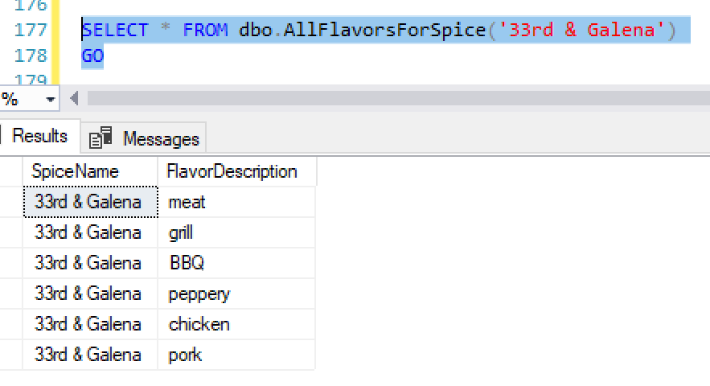

* **“I know other people have asked, but I can’t find it. Where’s the list of all the recipes we’ve collected?”**

/* Where's a list of all the recipes we've collected?

Equivalent to: Make a view of MealTypeName, RecipeName, and RecipeSource

*/

CREATE VIEW ListOfRecipesByMealType AS

SELECT MealType.MealTypeName, Recipe.RecipeName, Recipe.RecipeSource

FROM MealType

JOIN Recipe

ON MealType.MealTypeID = Recipe.MealTypeID

GROUP BY MealType.MealTypeName, Recipe.RecipeName, Recipe.RecipeSource

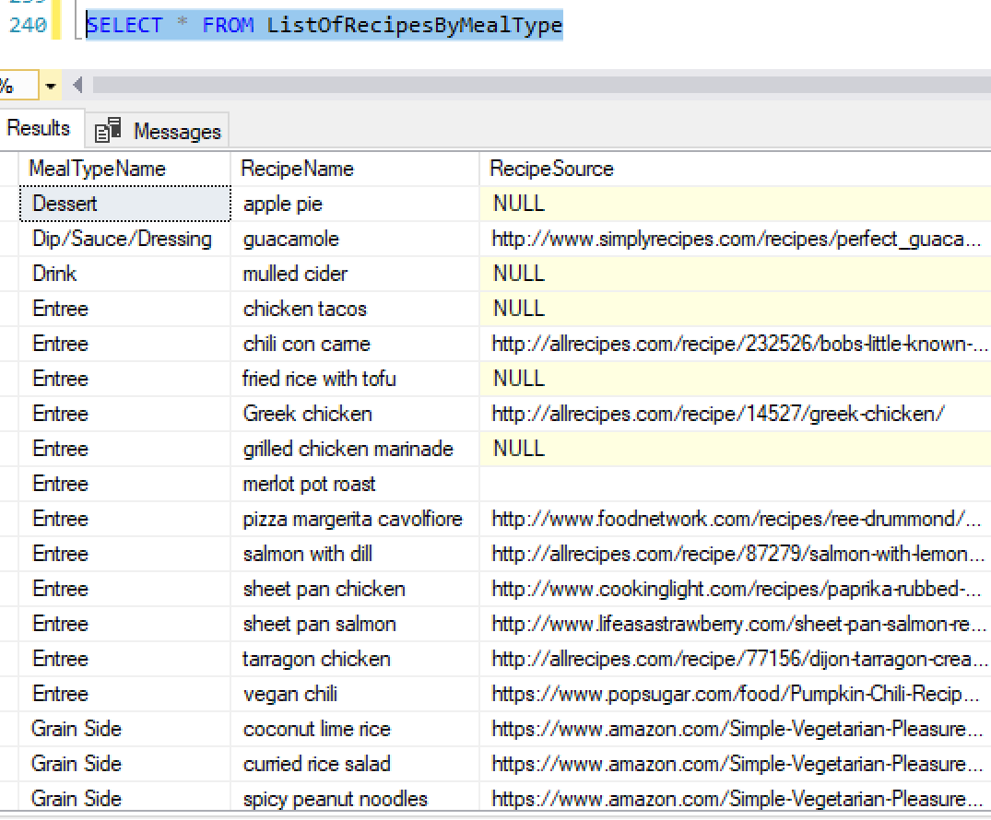

## Implementation

Although I like working in SQL, many users do not, so it is beneficial to make forms and reports that abstract the queries. Access allows us to make simple forms and reports that duplicate what we’ve done in SQL.

## Data relationships in Access

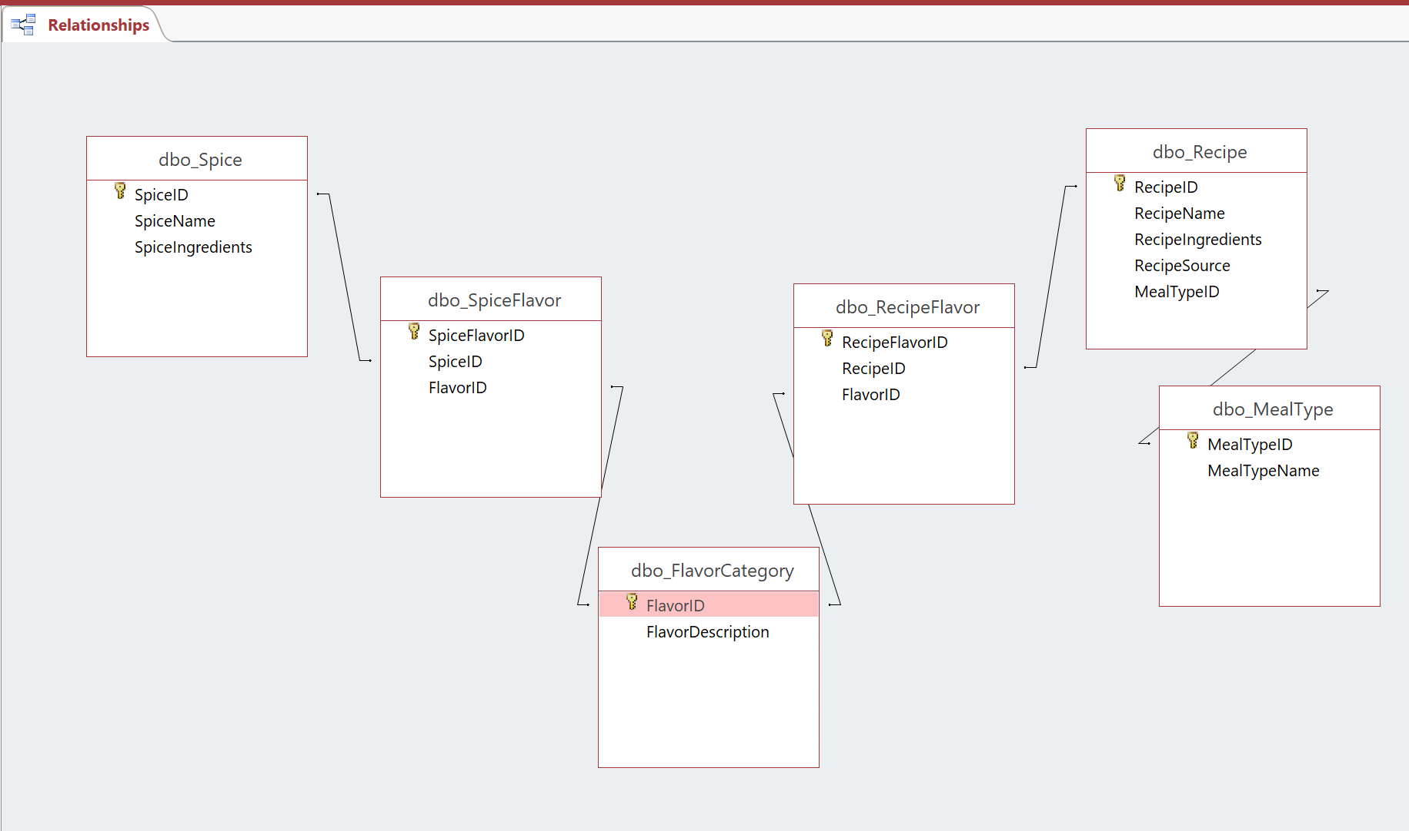

## Data maintenance

Access can be used to duplicate maintenance actions that were in the SQL, such as adding and updating records.

Add

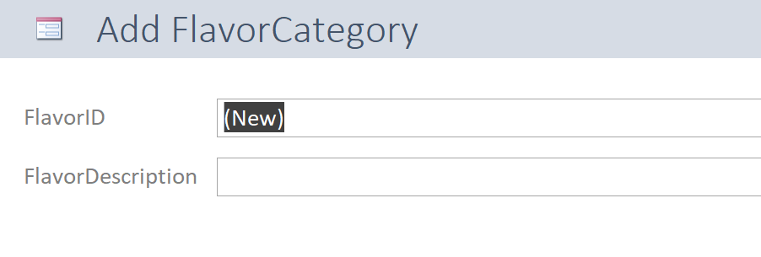

Update

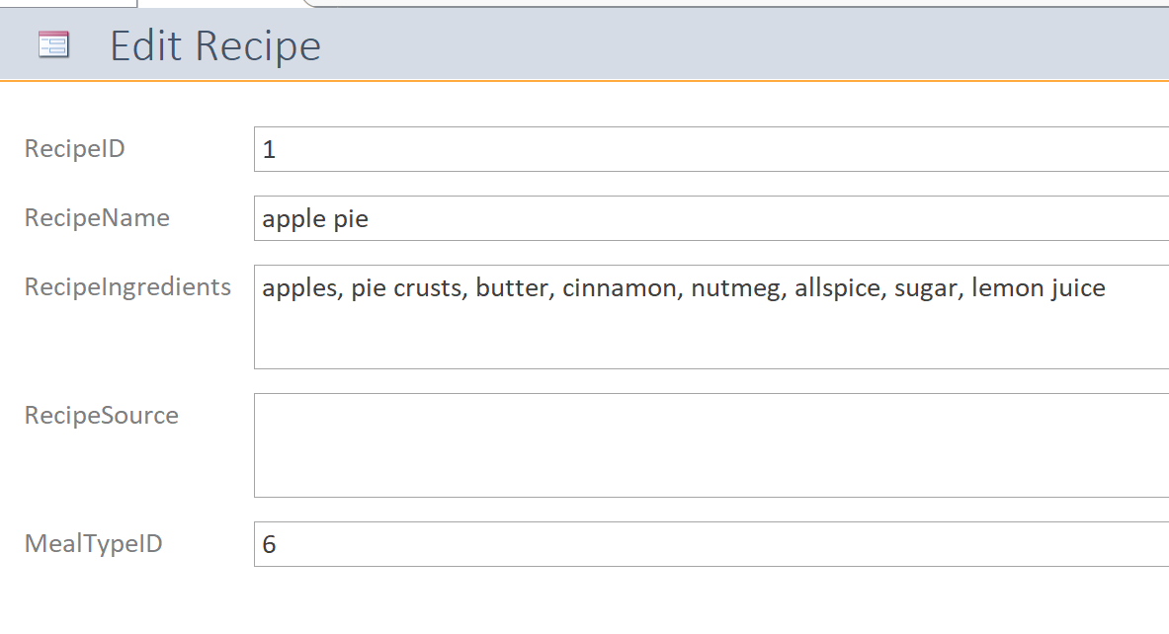

## Answer questions

You can also use Access to make more user-friendly ways of querying the database, without requiring users to learn SQL. These forms give the same results as the questions in the SQL section above.

**“I want to make an entrée that tastes herby. What should I make?”**

Form

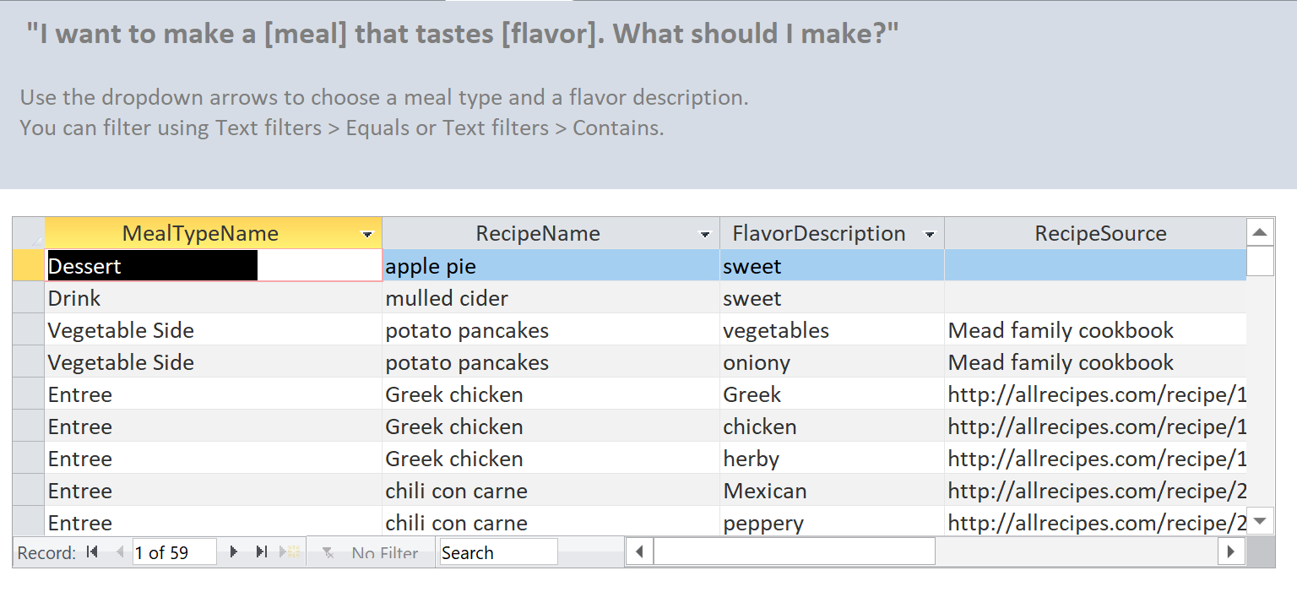

Sample query

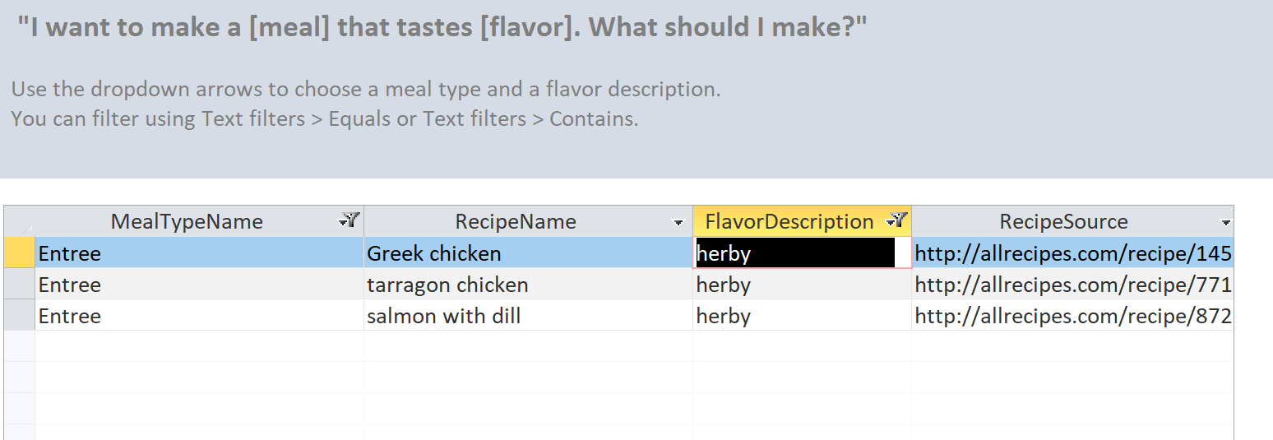

**“Which spices are peppery?”**

Form

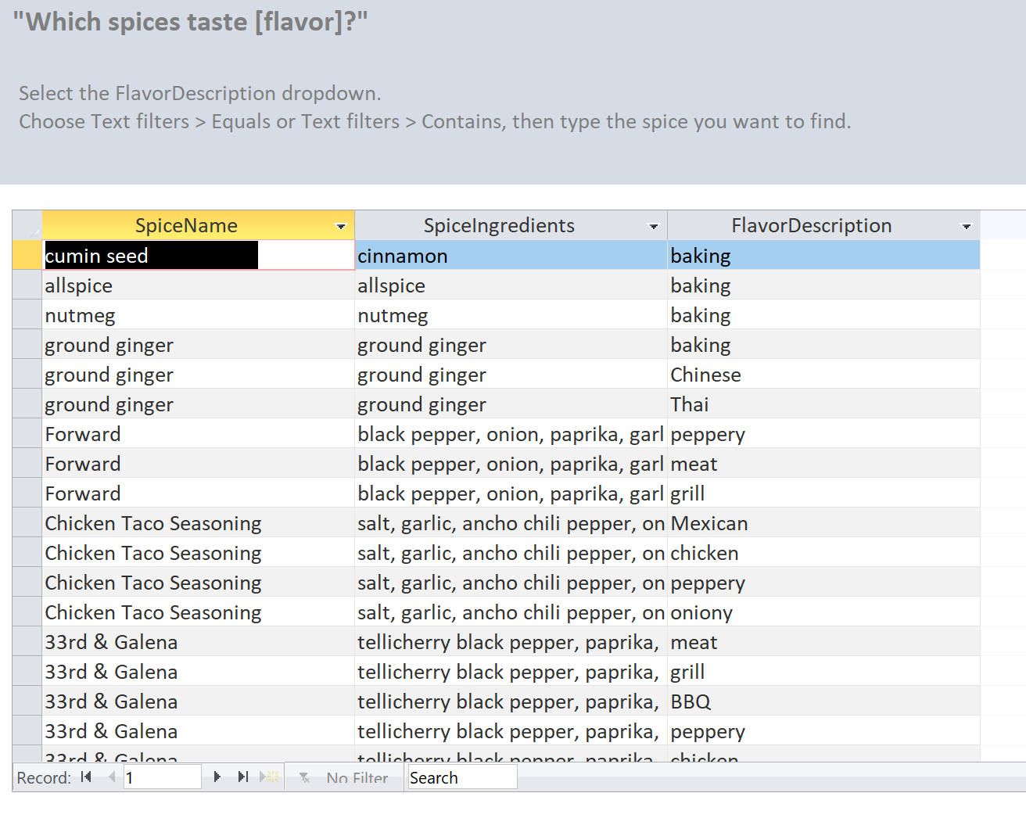

Sample query

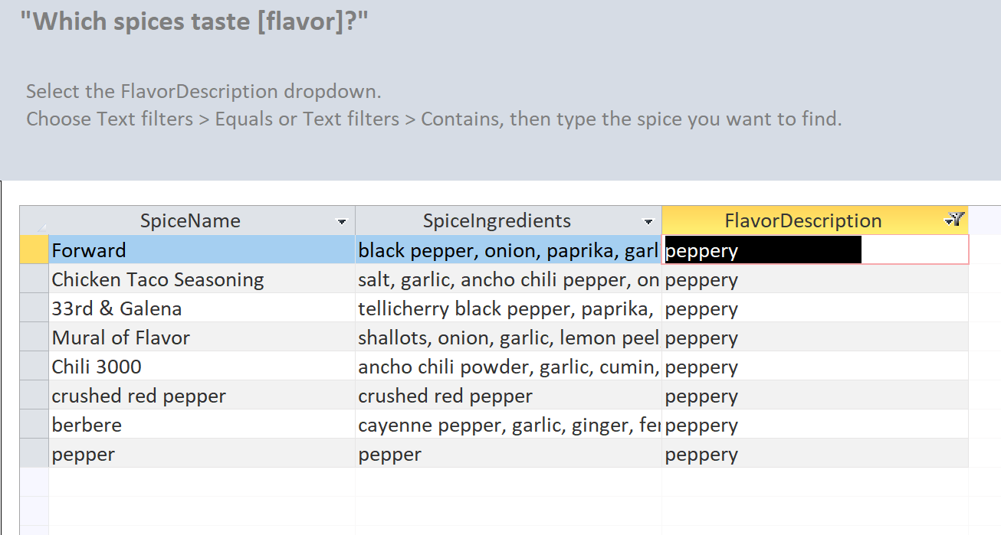

**“I have a ton of spaghetti squash. Which recipe should I try?”**

Form

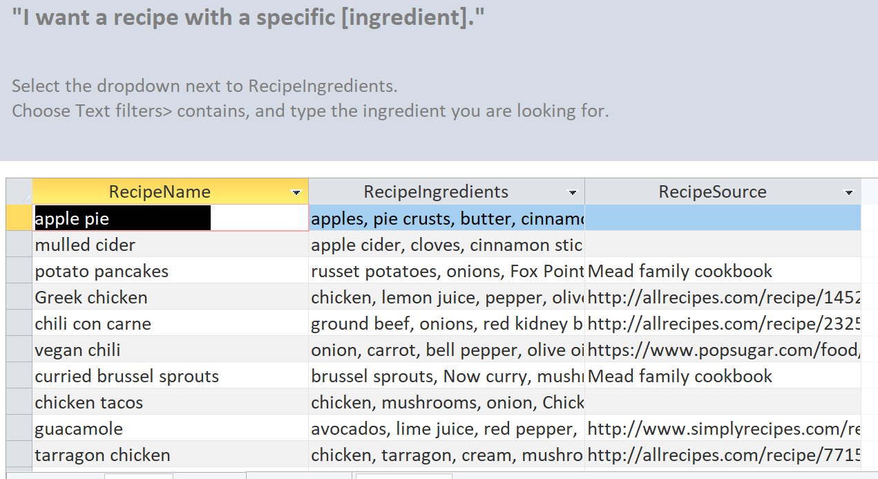

Sample query

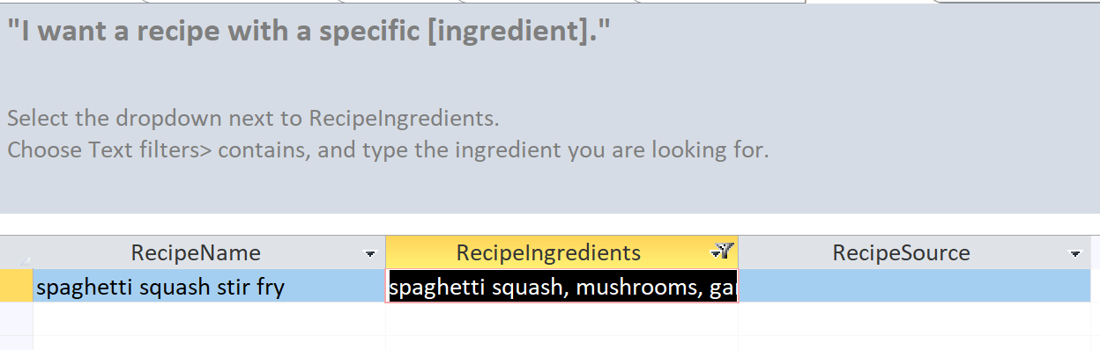

**“I’m allergic to turmeric and want to make a soup. What should I cook?”**

Form

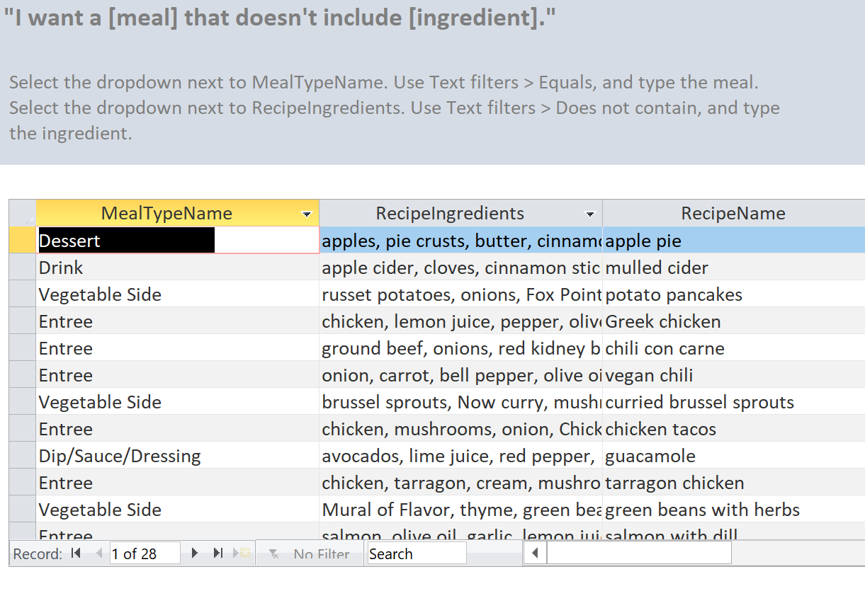

Sample query

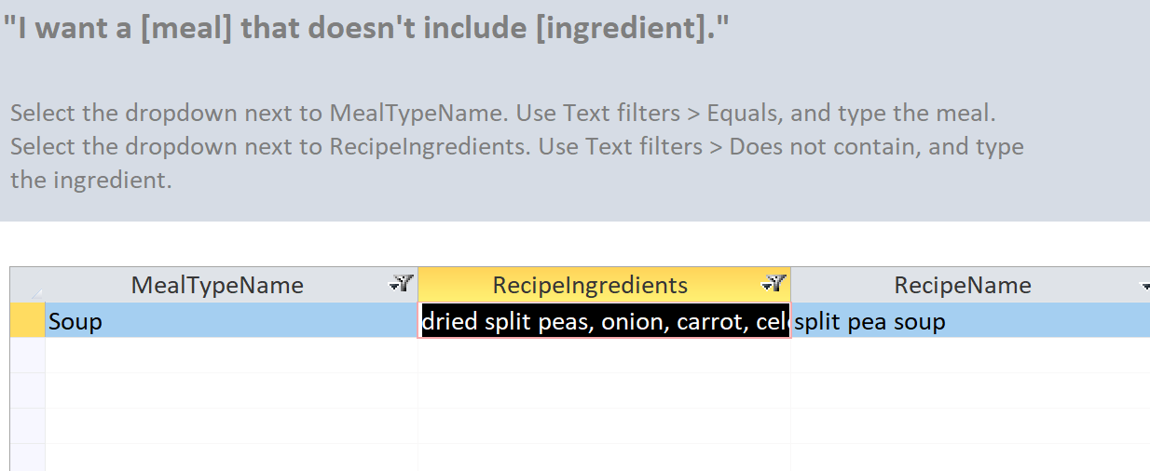

**“I just bought some 33rd & Galena [a spice blend]. What does it go with?”**

Form

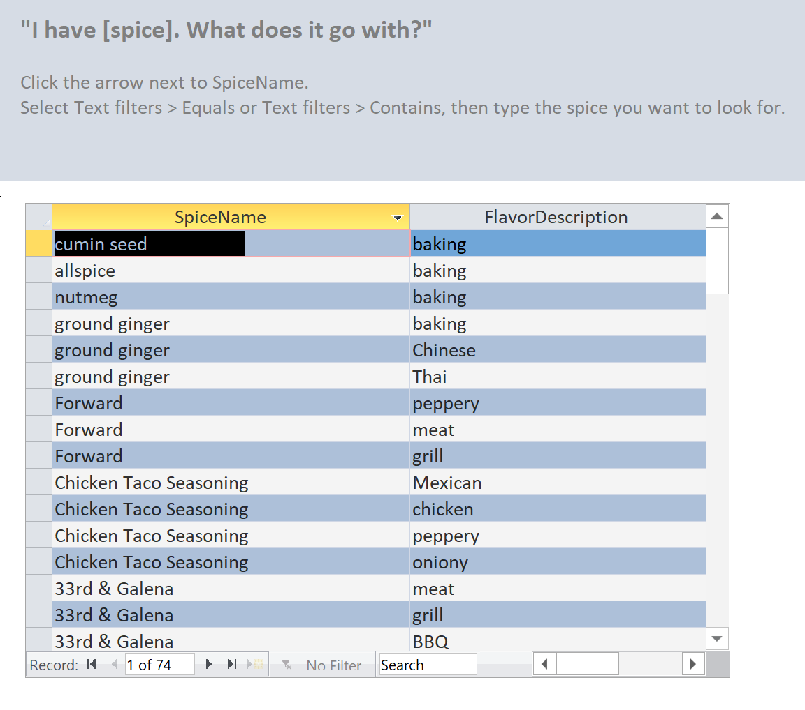

Sample query

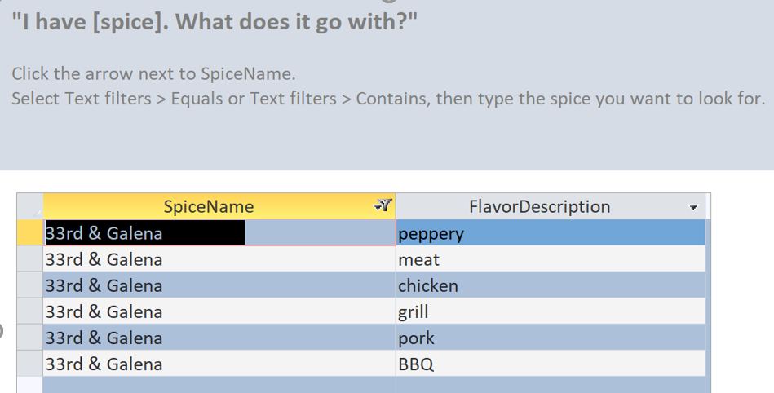

**“I know other people have asked, but I can’t find it. Where’s the list of all the recipes we’ve collected?”**

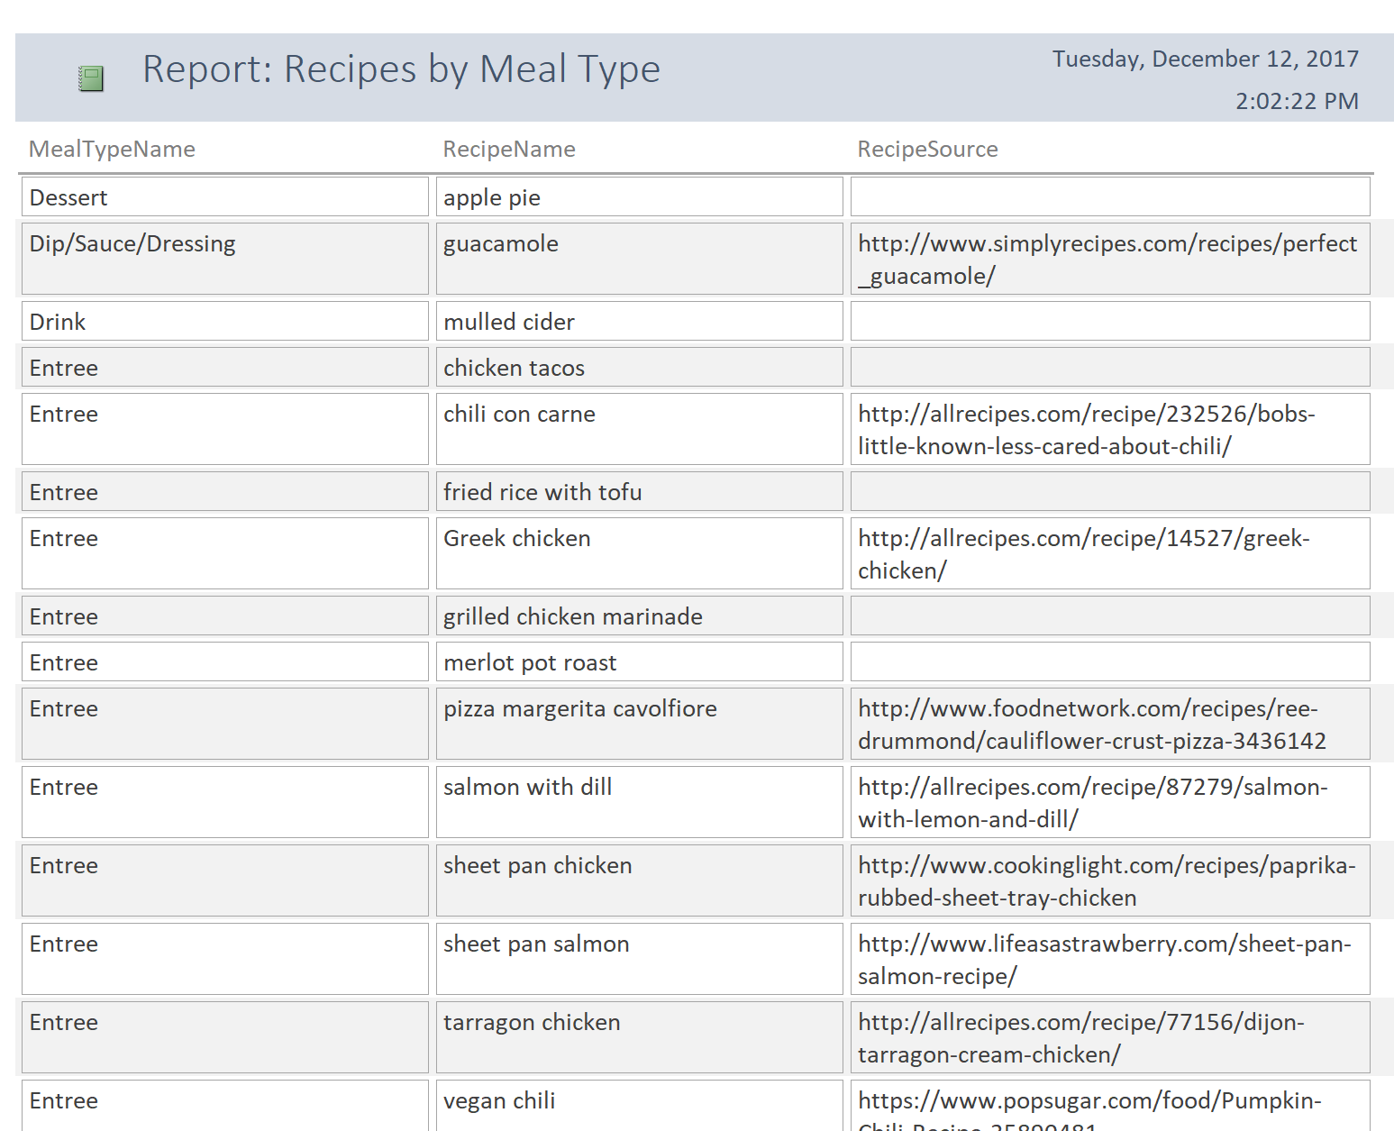

# Reflection

This was an interesting project. I got to combine a database with features of a recommendation engine and dabble with language processing. But in the real world, all of these things could be vastly improved.

## Data

More data leads to better results. I put only about 25 recipes in the database, so the query results are limited. If the Penzey’s site added recipes, they’d likely use the ones they’ve been printing in their paper catalogs for years. They could expand that by allowing user submissions, like the Facebook group does.

## Natural language in queries

It’s a losing battle to require user submissions that conform to strict standards. For example, there is no way that you can get everyone to agree to use “dill weed” instead of “dill”. A better approach is to make the language processing more flexible. I did a little of that, but not using exact match searches in some of my queries, but there’s a lot more to be done.

Google actually has a specific data type of “recipes” that encourages developers to follow tagging guidelines so that user recipes show up in Google search results. There may be some best practices to follow there. <https://developers.google.com/search/docs/data-types/recipes>

## User interface

The UI for this project was just a start. There are entire sites set up to share recipes, such as allrecipes.com. Their home page allows you to browse by category, search for a recipe by name, by ingredient, to “follow” a flavor or trend , and even to get personalized recommendations based on your searches and what you’ve saved to your “recipe box”. They even have a print magazine.

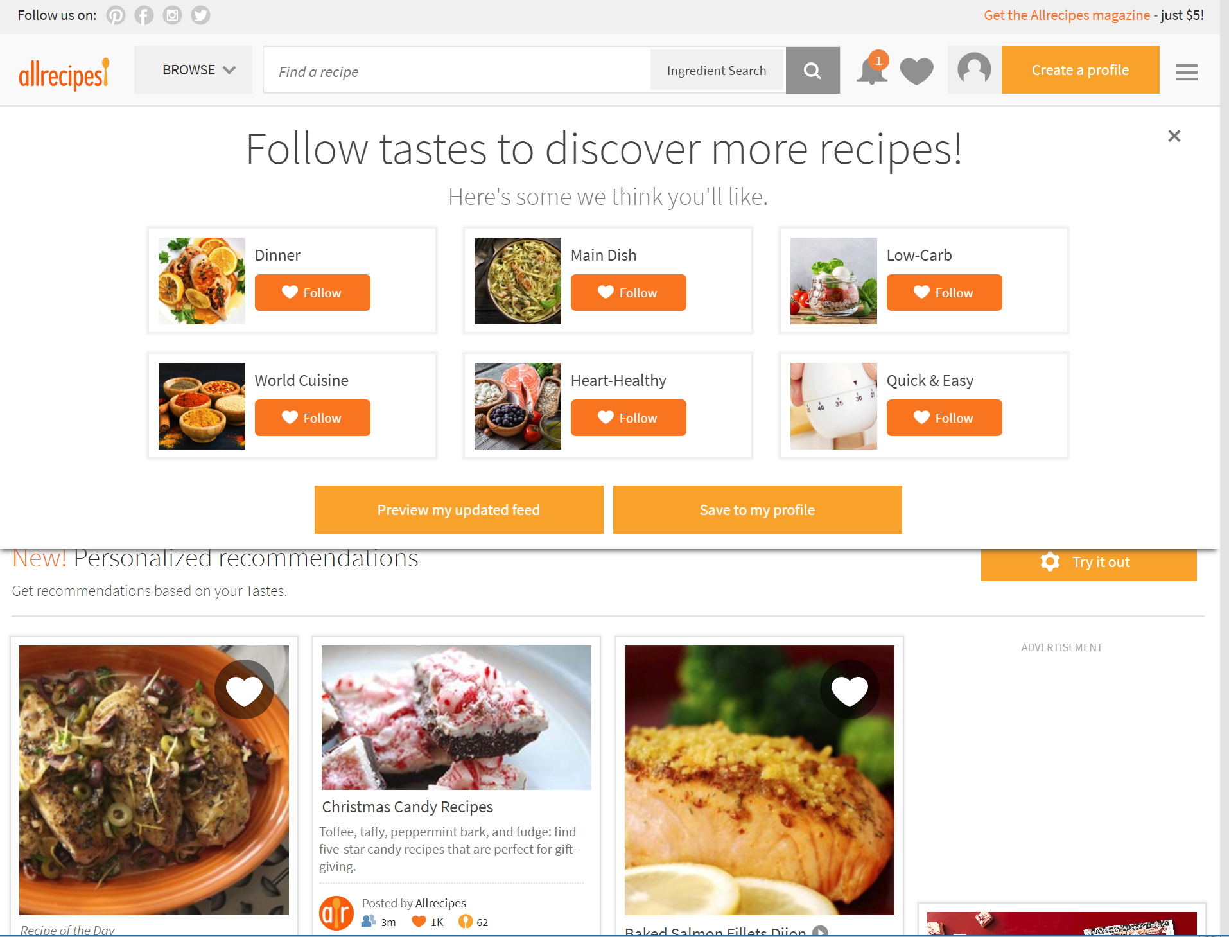

Pinterest has a different approach to recipes, but one that is very popular. All content is supplied by users, and users do all of the tagging. Then Pinterest focuses on using machine learning to find content that is similar to things that you’ve searched for or “pinned” (saved) in the past. Each image links to a website or more content within Pinterest itself.

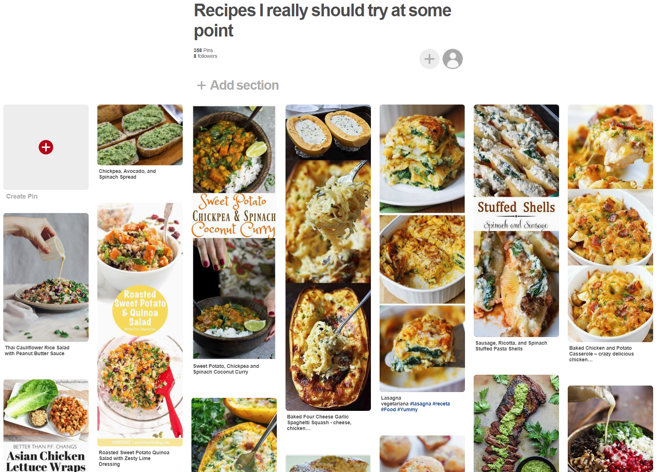

There are a lot of ways to approach a recipe UI; lots of opportunity here.

## What would I do differently?

Other than the obvious “if I had years of time and a team of 100, this could have been really awesome”, there are a few things I would change.

* I was happy with using Flavor as a connection between spices and recipes. It allowed for interesting connections between the data on several levels. But I would ideally have more ways to connect the tables. Country of origin, use in common diets, beginner vs. advanced cooking skills, etc.
* I would hold off on the UI until the data is richer. People search databases in order to get interesting results, and I’d make that the first priority.
* For a small database like this one, performance isn’t an issue, but as soon as it gets larger, the free-form text fields I used for ingredients would become cumbersome to search. Changing to a “tagging” method would improve search speed.